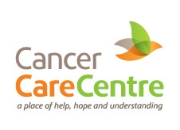

HERBS FOR HEALTH

HEALTH & WELLBEING with GARDEN HERBS by Herbalist: Sue Lohmeyer

With Herbalist: Sue Lohmeyer

A summer garden workshop (outdoors) exploring
the fascinating health & wellbeing benefits of Garden Herbs

A fascinating summer garden workshop (outdoors) exploring
the health & wellbeing benefits of Garden Herbs
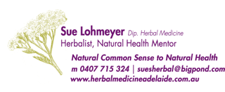
Join us to discover the joy of reconnecting with nature and growing your own health giving Garden Herbs. The additional benefits of garden herbs are fostering biodiversity such as butterflies, that add beauty to our garden.
Everything we do matters, never underestimate the impact you can have towards positive change.

WHEN: WEDNESDAY 16TH FEBRUARY 2022
10am - 12noon

WHERE: CHERINGTON HOUSE THERAPEUTIC COMMUNITY GARDEN
13 LAFFERS RD. BELAIR
(Adjacent to INTEGRATIVE HEALTH SOLUTIONS
formerly The Blackwood Hospital)

COST: $45 Non-Members / $30 CCC Members

BOOKINGS ESSENTIAL
PHONE 8272 2411
ENQUIRIES: 0407 339 660

